Introduction

Purpose

The purpose of our project is to read data in from API’s and display the data in a

Useable way for interpretation

Scope

Our project will be based on augur and will be pulling data from it

Assumptions and dependencies

We will depend on augur apis to get our data from

We assume the user is looking for data in augur

Software product overview

Our project will be available via website and will operate on a github.io

Our product will display augur data in a helpful way to be interpreted

The augur data that we will be focusing on are from the contributors and commiters that work on augur projects

System use (actor survey)

Our system will be used by:

users who wish to learn more about the inner workings of augur

augur contributors to see who is getting what done

frontend developers who will maintain the site and look after issues that may arise

System requirements

Use cases

Loading api data-

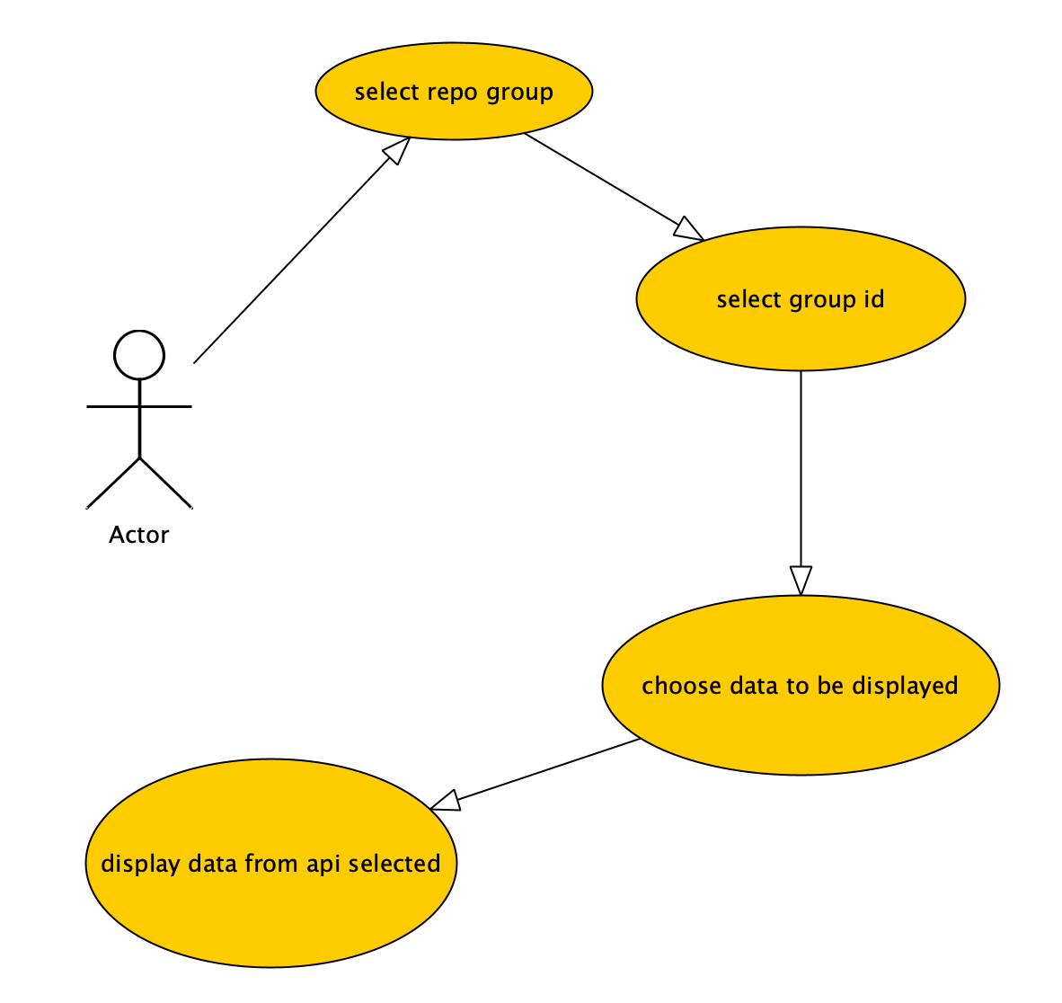

If api data is empty-

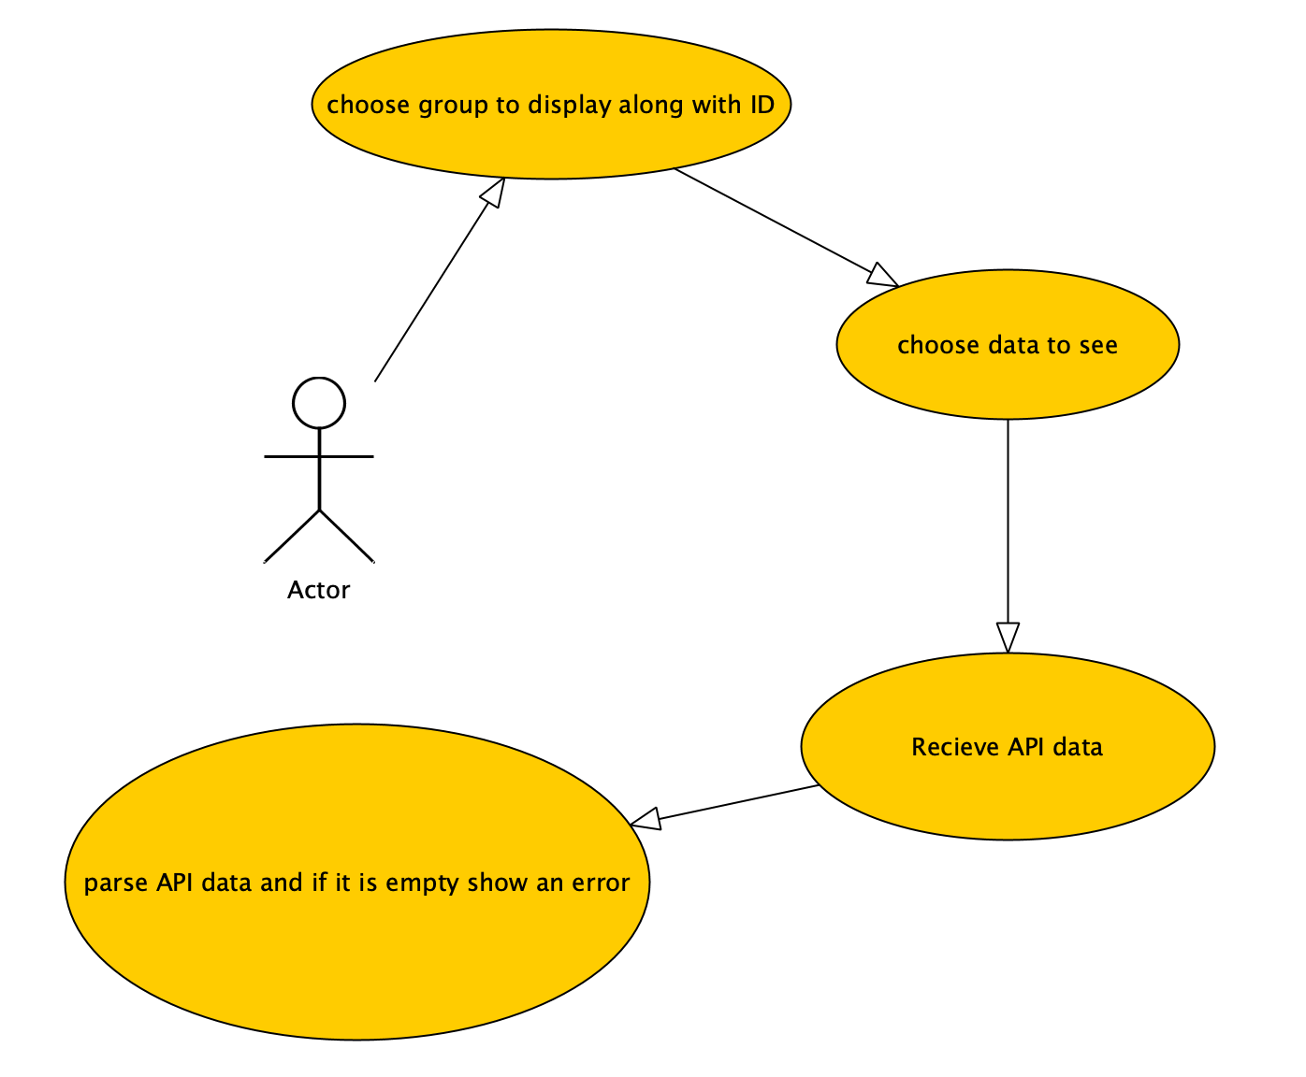

System functional speculation

The system will display API data from user chosen groups, ID’s and data that they

Wish to see, they will be given an error if the data is empty or will be given data if it exists

Non functional requirements

Viewable data

Must be easy to use

Readme for how it runs

Easy to navigate

Design constraints

Must be a usable software for most people

Must solve the problem in a quick and efficient way

Must display data in a readable way

Must be responsive

Must be online and accessible for anyone on mobile

Purchased components

Web dev languages(html, javascript, php,css)…………. free

Github.io …………….. free

Servers for deployement …………. free

Interfaces

The interface will look like a blank page when it first loads, there will be a nav bar at the top of the screen with multiple selection windows that have all the repos and groups contained within. There will be another drop down menu with selection options that will allow you to specify what type of data you wish to see. Lastly there will be a button that starts the search for the data. The data will be displayed in the whitespace below the nav bar.